ASSIGNMENT 40

Name : Akanksha Joshi

Roll No : B038

Batch : 3

Div : BTech CS B

-------------------------------------------------------------------------------------------------------------------------------------------

Source Code

1.

import random

i=0

for i in range(0,10):

op=random.randrange(100,1001,100)

print("Random Number is : ",op)

2.

import random

op=random.randrange(31,51)

f=0

while(f==0):

if(op%2==0):

print(op)

f=1

else:

op=random.randrange(31,51)

continue

Output

1.

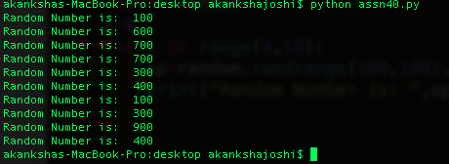

2.

